ISTR Ventilation Workshop (27-28 June) and Biological Safety Officers meeting (29 June)

Rail Stations and Hotel locations relative to Camfil Ltd

Red Hall Hotel
The Village Hotel, Bury
Dunkenhalgh Hotel and Spa (Mercure, Blackburn)

NB The prices shown on the maps are indicative - shown on Google Maps on 8 May 2023

Relative locations of Rail/Tram stations, Hotels and Camfil Ltd

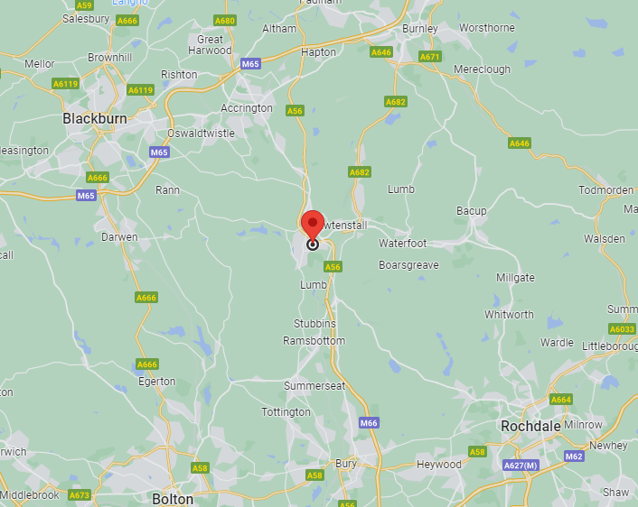
Red Hall Hotel
Dunkenhalgh Hotel & Spa
The Village Hotel
Red Hall Hotel website Great Value Manchester Hotel | Red Hall Hotel Bury (red-hall.co.uk)
Route by car from Red Hall Hotel to Camfill via A56 (approx. 5miles)
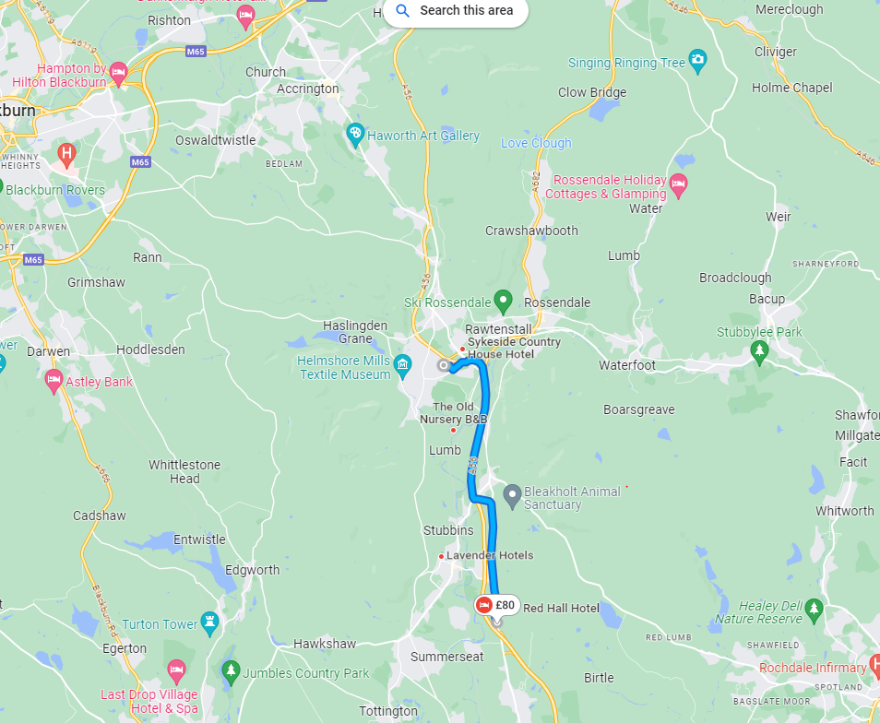

The Village hotel, Bury website Village Hotel Manchester Bury | Hotel Stays Near Rochdale (village-hotels.co.uk)
Route by car from The Village Hotel, Bury to Camfil Ltd via M66 & A56 (approx 9miles)
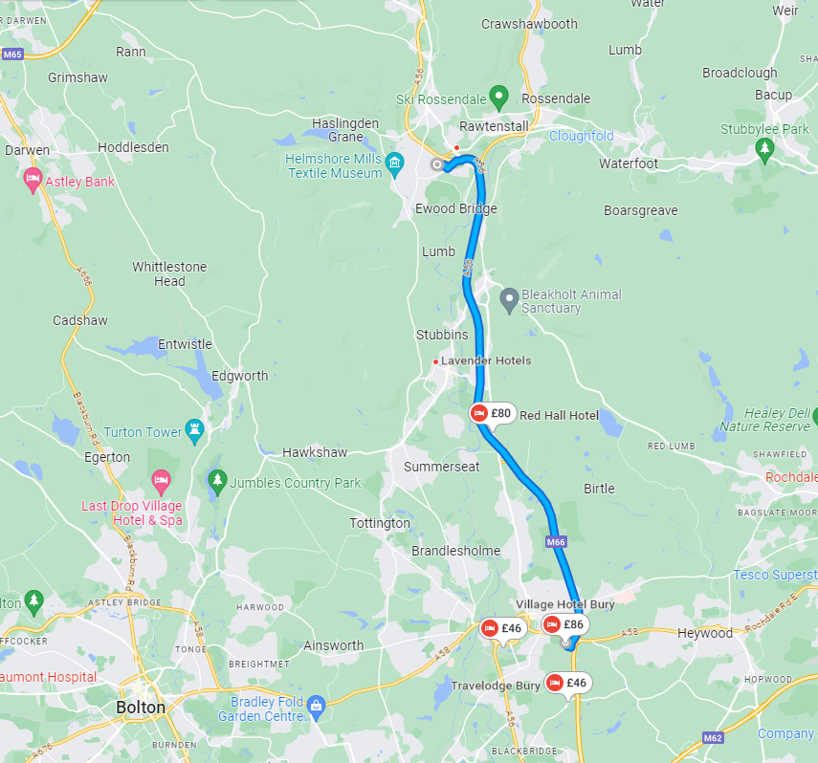

The Dunkenhalgh Hotel and Spa website Mercure Blackburn Dunkenhalgh | Hotel & Spa Blackburn - ALL (accor.com)
Route by car from Dunkenhalgh Hotel and Spa to Camfil Ltd via M65 and A56 (approx 11miles)

