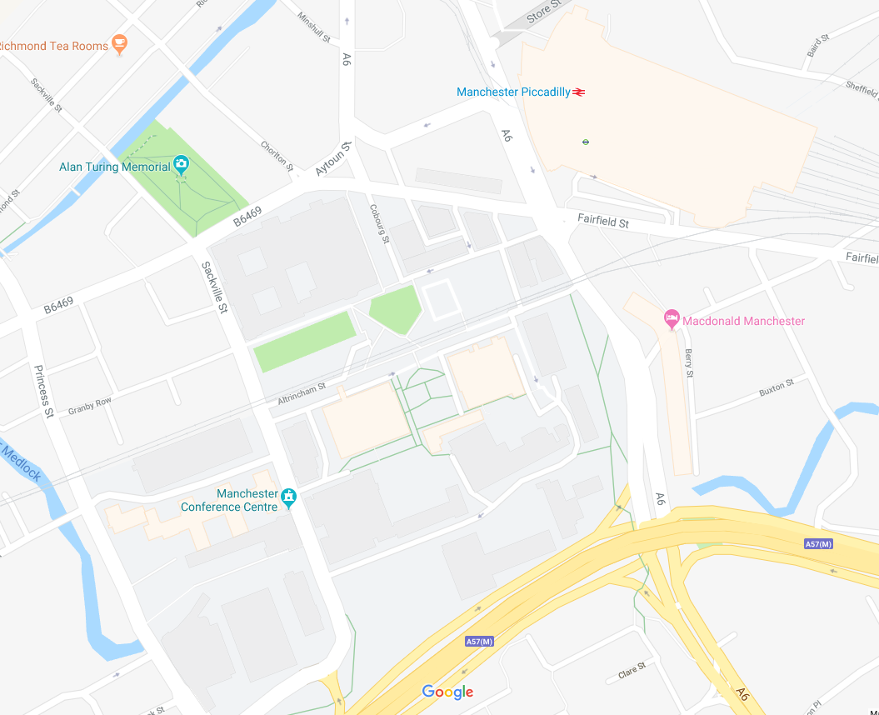

Charles St Car Park

Granby Row

Exit station